TABLE OF CONTENTS

SL.NO | CONTENT
1. | AIM
2. | ABSTRACT
3. | PROBLEM STATEMENT
4. | OBJECTIVES
5. | METHADOLOGY
6. | PROJECT MILESTONES
7. | RESULTS
8. | FUTURE SCOPE
9. | CONCLUSION

TO SUPPLY LEFTOVER FOOD TO POOR USING SALESFORCE

1. AIM
The main aim of this project is to develop a Salesforce-based cloud application that redistributes leftover food to the poor efficiently and transparently. This system acts as a digital bridge between food donors, NGOs, and volunteers, ensuring that edible food is collected and delivered before spoilage.
The application automates workflows using Salesforce objects, triggers, flows, dashboards, and reports, helping to:
- Reduce food wastage
- Promote social responsibility
- Streamline NGO operations
- Contribute to hunger-free and sustainable community development

2. ABSTRACT
Food wastage is a major concern in modern society, where vast amounts of food are discarded daily while millions of people go hungry. An organized approach is required to redistribute this surplus food to those in need.
This project proposes a Salesforce-based platform that connects food donors (restaurants, households, events) with NGOs and volunteers. The platform leverages Salesforce CRM tools to automate donation management, notifications, and delivery tracking.
By using Salesforce cloud technology, the system ensures real-time updates, centralized data management, and automated reporting, ultimately supporting sustainability and hunger eradication efforts.

3. PROBLEM STATEMENT
Despite abundant food production, hunger persists due to poor food redistribution management. Manual donation systems are inefficient, lack communication, and result in food spoilage.

Challenges:
- No centralized tracking for surplus food.
- Communication gaps between donors and NGOs.
- Delayed pickup and lack of accountability.
- Absence of automated reporting and analytics.
This project aims to create a Salesforce-powered cloud solution to automate and organize the process of connecting donors with NGOs, ensuring faster delivery and minimized wastage.

4. OBJECTIVES
- Develop a cloud-based Salesforce application for food donation management.
- Connect donors, NGOs, and volunteers through a single unified system.
- Automate notifications and food collection workflows using Flows and Triggers.
- Visualize reports and dashboards to monitor operations.
- Encourage sustainable practices and minimize food waste.

5. METHODOLOGY

System Workflow:
- Donor Registration: Donors register via the Salesforce portal.
- Food Entry: Donors submit food details such as type, quantity, and pickup time.
- Automated Matching: The system identifies nearby NGOs and sends notifications.
- Pickup & Delivery: Volunteers collect and deliver food to the needy.
- Tracking & Reporting: Dashboards show ongoing donations, total meals served, and delivery details.

Salesforce Features Used:
- Custom Objects & Relationships
- Workflows & Flows for Automation
- Apex Triggers for Real-time Updates
- Reports & Dashboards
- Role-based Profiles & Permissions
- Community Portals for External Users

6. PROJECT MILESTONES

Salesforce Developer Account Creation
Created a Salesforce Developer account to build and test the application in a secure environment.

Object Creation
Defined custom objects like Donor, Food Item, NGO, and Delivery Record for data storage and relationship management.

Tabs
Tabs were created to make these objects accessible through the Salesforce interface.

The Lightning App
Developed a Lightning App to integrate all features in a unified dashboard.

Fields
Added custom fields (food type, quantity, expiry date, location, contact details) to enhance data collection.

Flows
Implemented Flows to automate NGO notifications when new donations are registered.

Triggers
Used Apex Triggers to perform real-time updates and ensure quick responses.

Profiles
Configured profiles to manage access levels for Admins, Donors, NGOs, and Volunteers.

Creation of Users
Created multiple users under various roles to simulate real-world operations.

Public Groups
Formed public groups for bulk communication among NGOs and volunteers.

Report Types
Developed custom report types to merge related objects for analytics.

Reports
Built reports to track donations, delivery success rates, and active donors.

Dashboards
Designed interactive dashboards displaying overall performance metrics and total meals served.

Sharing Rules
Established sharing rules to maintain proper record visibility and data security.

Home Page
Customized the Home Page with quick access components like active donations, NGO requests, and alerts.

Conclusion
After successful testing, the Salesforce application achieved its objective of connecting food donors and NGOs effectively.

7. RESULTS
- A complete Salesforce application was developed for food donation management.
- Donors could list leftover food instantly, and NGOs received automatic alerts.
- Reports and dashboards provided a clear view of ongoing and completed donations.
- Reduced food wastage through faster pickups and delivery tracking.
- Promoted digital transformation in social welfare initiatives.

FORM
(VENUE,TASK,DROP-OFFPOINT,EXECUTION DETAILS,VOLUNTEER)
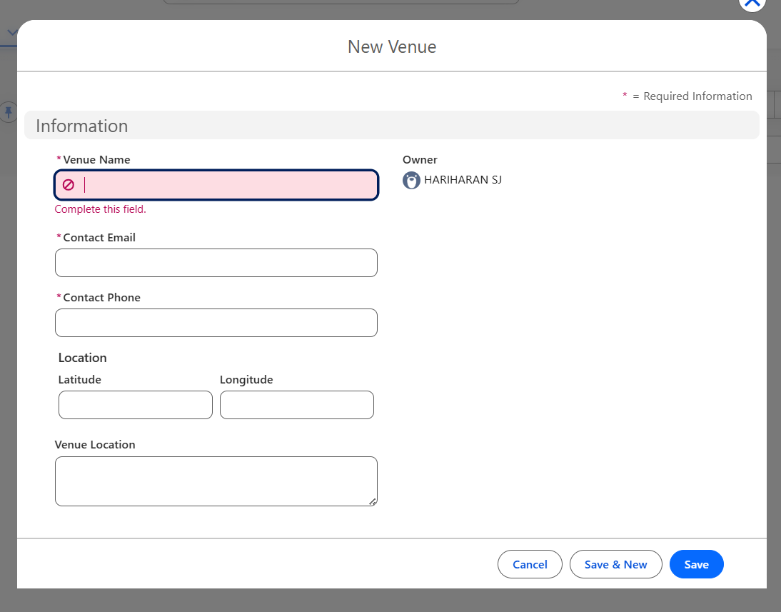

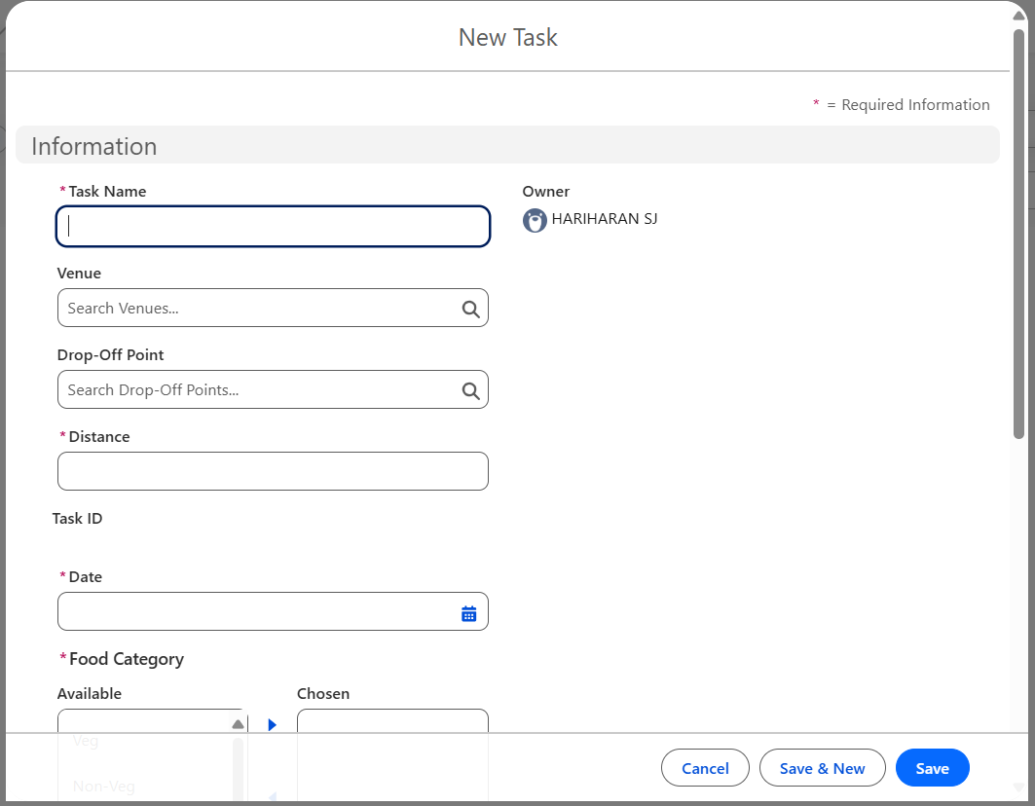

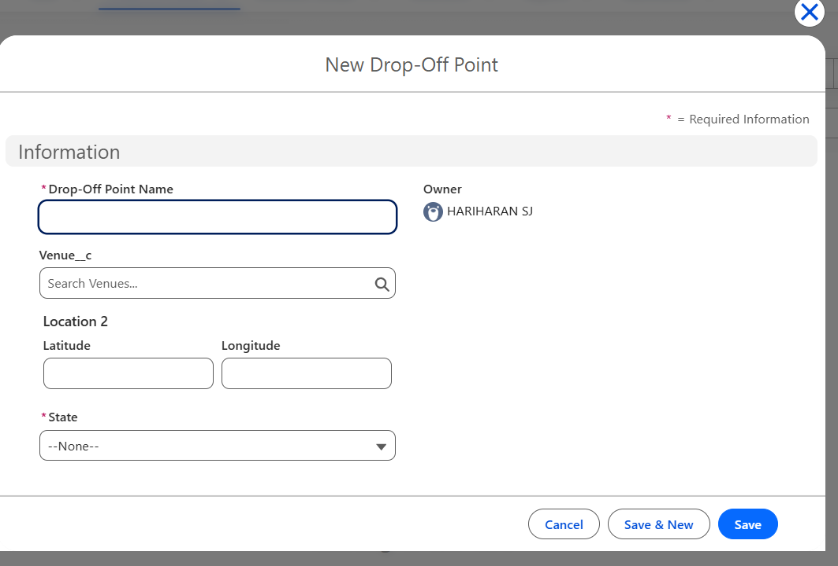

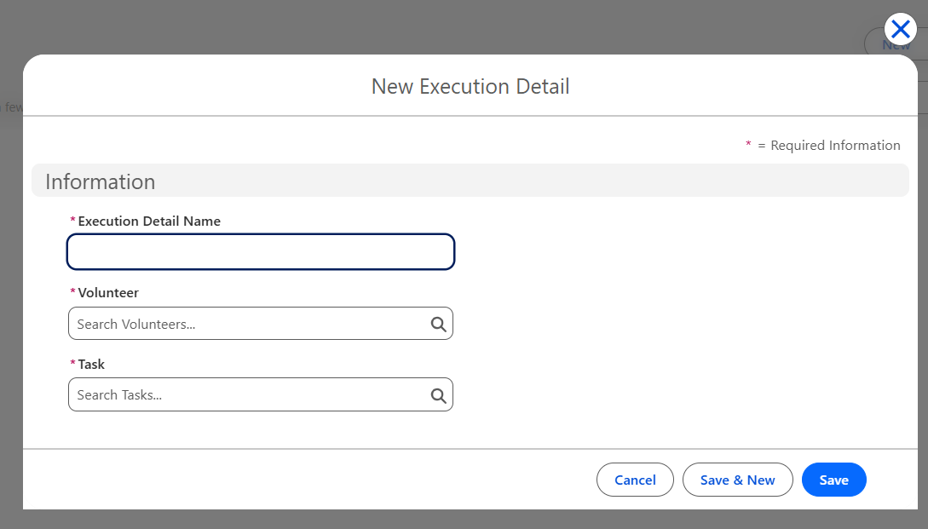

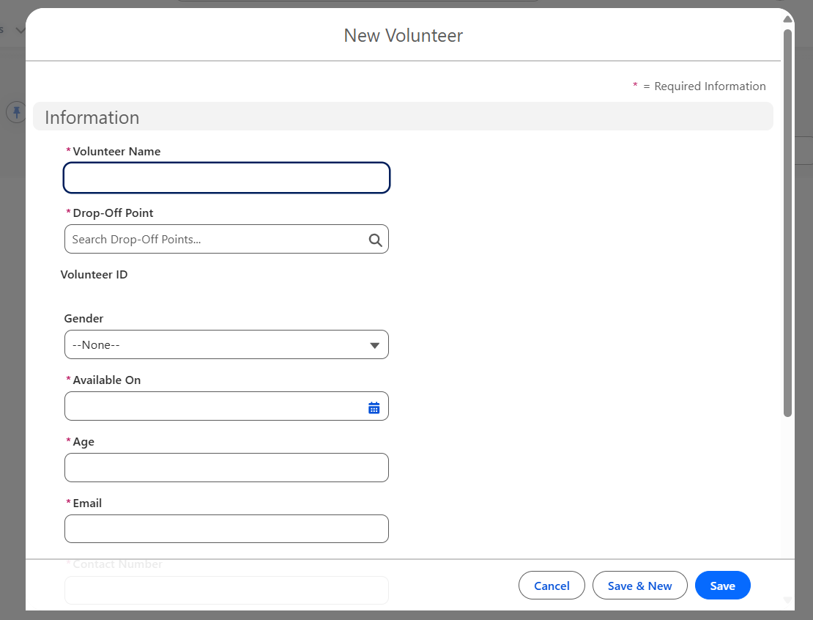

OUTPUT IMAGE (FOOD CONNECT LIGHTNING APP)
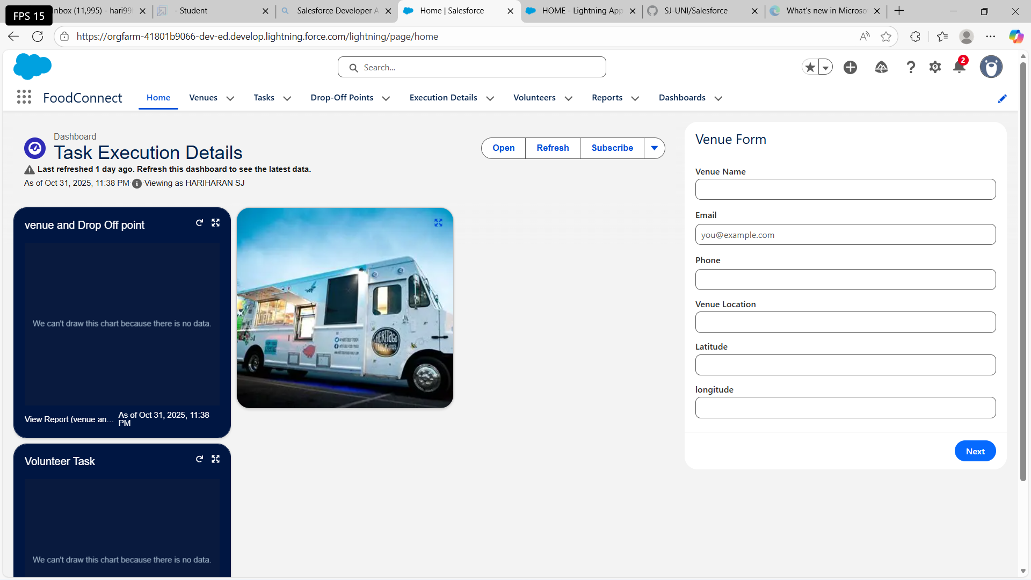

8. FUTURE SCOPE
- Mobile App Integration: For easier donor access and NGO notifications.
- AI-Based Prediction: To forecast donation trends and area-wise demand.
- Geolocation Services: For real-time tracking of food pickups and deliveries.
- SMS/Email Automation: For instant communication and reminders.
- Blockchain Integration: To maintain transparency and traceability of donations.

9. CONCLUSION
The Salesforce-based 'Leftover Food Supply System' successfully demonstrates how cloud technology can solve real-world social challenges. By connecting donors and NGOs through an automated platform, it ensures efficient food redistribution, transparency, and accountability.
This project not only reduces food waste but also promotes social responsibility and sustainability, supporting the vision of a hunger-free community.

